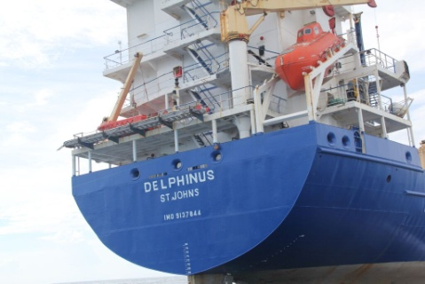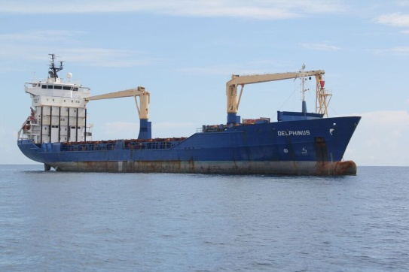
US MARSHAL SALE
SOUTHERN DISTRICT OF FLORIDA
M/V Delphinus
IMO 9137844
Container Ship Built 1997, Turkey
IMO Number 9686338

TO ARRANGE INSPECTION or FOR ADDITIONAL INFORMATION
RON BROZIC * (954) 990-1052

DATE/TIME: August 11, 2016 commencing at Noon EDST
LOCATION: United States Courthouse, 299 East Broward Blvd, Fort Lauderdale, Florida, USA
MINIMUM BID: US $100,000

Vessel sold as is, where is. Purchaser will receive a Bill of Sale stating that the title to the Vessel is FREE and CLEAR of ALL ENCUMBRANCES.

VESSEL DETAILS
Name: Delphinus
Build: 1997, Turkey, GL Class
IMO Number: 9137844
Flag: Antigua flag, Port of Registry St. John's
Gross/Net Tonnage/Size 5,730/2,759/LOA 121.93M, Beam 19.28M
Containers: Hold 168 teu / deck 435 teu - total 603 teu
Reefer sockets: Hold 50 /decl 100 - total 150
Power: MAN B&W main engine, 6,300 Kw / 8,800 HP
Aux: 2 x 640 Kw / 960 HP
Emergency: 1 x 172 Kw / 240 HP
Bowthruster: 400 Kw / 600 HP
Speed and Consumption: 100 % load = 16 k on 24.5 mt, 50 % load = 13 k on 20 mt, 25 % load = 7 k on 7 mt

“Details believed to be correct but without guarantee”

